DEAR FAMILIES,
WE HOPE THAT YOU ARE CONTINUING TO STAY SAFE AND WELL. PLEASE NOTE THAT THESE ASSIGNMENTS SHOULD BE WORKED ON A LITTLE AT A TIME EACH DAY. PLEASE DO NOT FEEL LIKE YOUR CHILD NEEDS TO WORK ON CLASSWORK ALL DAY. THEY ARE MEANT TO BE HELPFUL, NOT STRESSFUL. THANK YOU FOR ALL THAT YOUR ARE DOING WITH YOUR CHILD AT HOME. WE MISS YOU!
SENDING LOVE,
MRS. PICCIRILLO, MISS AVERSA, MISS EVERTS, & MRS. JONES

ASSIGNMENTS FOR 5/18-5/22

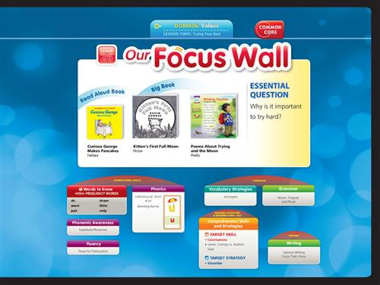

TOPIC- Trying Your Best
SIGHT WORDS- do, went, just, down, little, only

Read Aloud Book: Curious George Makes Pancakes
https://www.youtube.com/watch?v=g9ig8rJ4F9E

Big Book: Kitten’s First Full Moon
https://www.youtube.com/watch?v=PacweS54au0

ELA-
- Click below to listen to the story online- Curious George Makes Pancakes
https://www.youtube.com/watch?v=g9ig8rJ4F9E

- Writing- Opinion Writing:
Do you like pancakes? Why or why not?
(EXAMPLE: I like pancakes because you can pour syrup on them.)
(EXAMPLE of a picture to match: draw a picture of you eating pancakes)
FUNdations Writing Paper
- 5 minutes of fun ELA from our ELA page
Sight words- do, went, just, down, little, only
Suggestions for Sight Words-
Practice writing words, use them in a sentence, do a word hunt in your favorite book, write them on flash cards!

Math-
Complete the math review sheet below:
Math Review

Complete the word problem using 2 different ways to solve:
Math Word Problem

Complete the shapes hunt sheet below:
Shape Hunt at Home

Complete the teen numbers sheet below:
Teen Numbers

FUNdations-
CVC-e long U video
https://www.youtube.com/watch?v=DCSBi7Gz6jQ
Practice tapping out, reading, & writing CVC-e words: (Focus on the long /u/ sound)
CVCe U Words
Here are a few more words to practice:
Use
Cube
Glue
- Practice long vowel /U/ words here:
- Complete this long and short vowels worksheet below:
Long U and Short U

Complete the silent e sheet below:
Make Silent E words

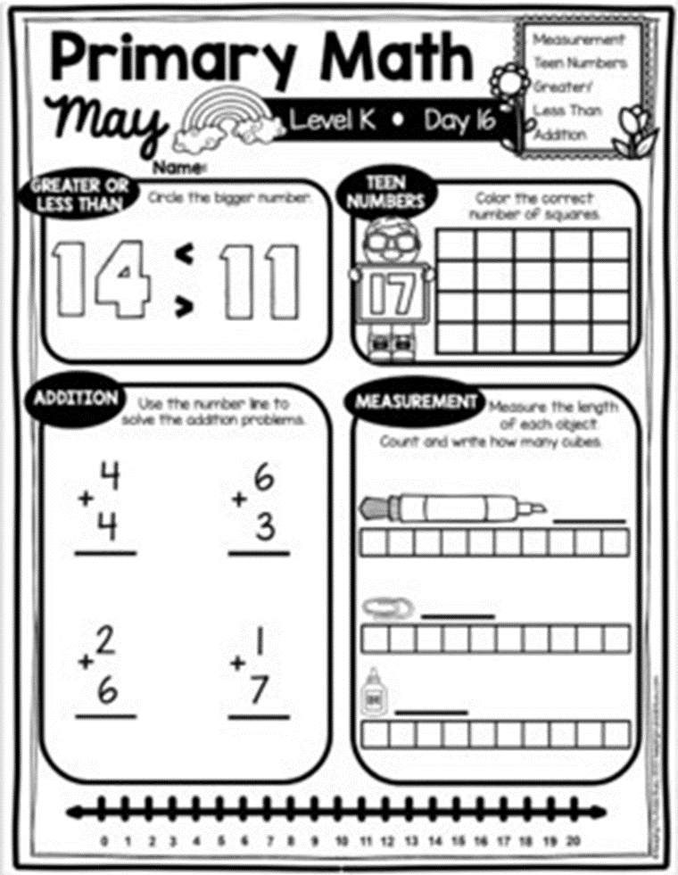

Name: ________________________________________________________

Jase and Josiah went to the park. They saw 5 ducks swimming and 7 birds flying. How many animals did they see?

Please be sure to solve the problem in 2 different ways and write the matching number sentence.
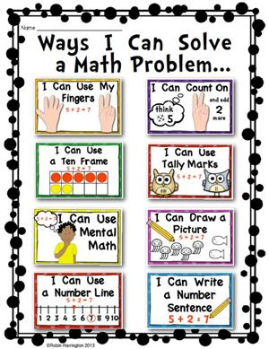

Name: ______________________
Look around your house! Draw a picture of 1 or 2 things that match each shape!

Square

Circle

Triangle

Oval

Rectangle

Rhombus (diamond)

